Place Directorate

Address via mail merge

Date: 16th May 2025

Dear All,
Babergh District Council - Bentley Conservation Area Designation

As you may be aware Babergh District Council designated a new Conservation Area for part of Bentley on 23rd April 2025.
The Interim Chief Planning Officer has asked that this letter and accompanying Conservation Area boundary plan be sent to properties with the new Bentley Conservation Area to provide you with relevant information.
The web link and QR code below both provide a short cut to access all relevant information and we hope that you find these helpful.
https://www.babergh.gov.uk/conservation-area-consultations
The Council has, as required by the Planning (Listed Buildings and Conservation Areas) Act 1990, placed Public Notices in both the London Gazette Friday 16th May and a local newspaper The East Anglian Daily Times on Saturday 17th May to announce the Designation.
Full details of the effect of designation, and copies of the Council’s supplementary planning guidance booklet on “Conservation Areas”, can be viewed at the following website address. www.babergh.gov.uk/conservation-areas
The existence of the Conservation Area will be revealed by Local Land Charge Searches against all properties within the boundary shown on the definitive plan.

Please Scan:
Yours faithfully

Philip Isbell
Interim Director of Place
Babergh and Mid Suffolk District Councils

The boundary of the newly ‘Designated’ Bentley Conservation Area

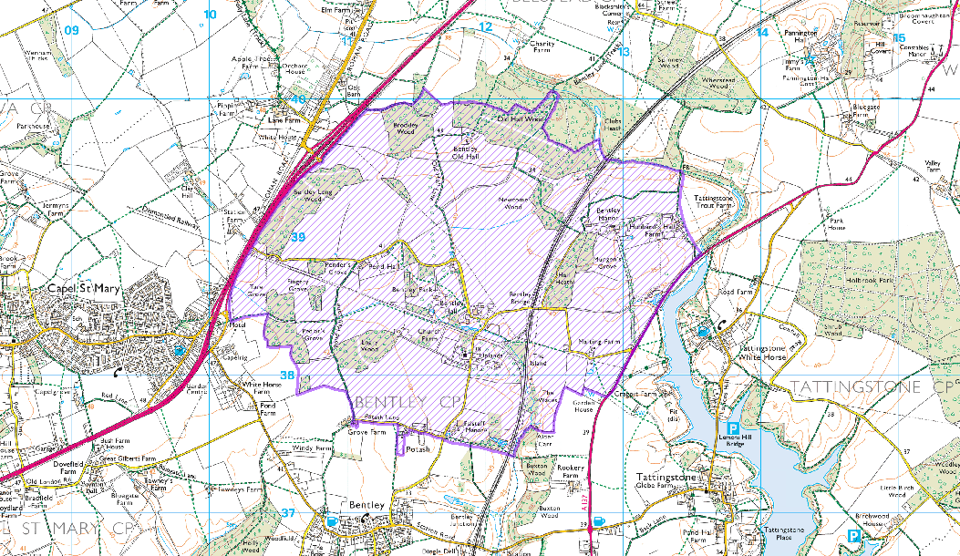

figure 1: The boundary of the newly ‘Designated’ Bentley Conservation Area

