CLAYDON

HOUSING & POPULATION DATA PROFILE
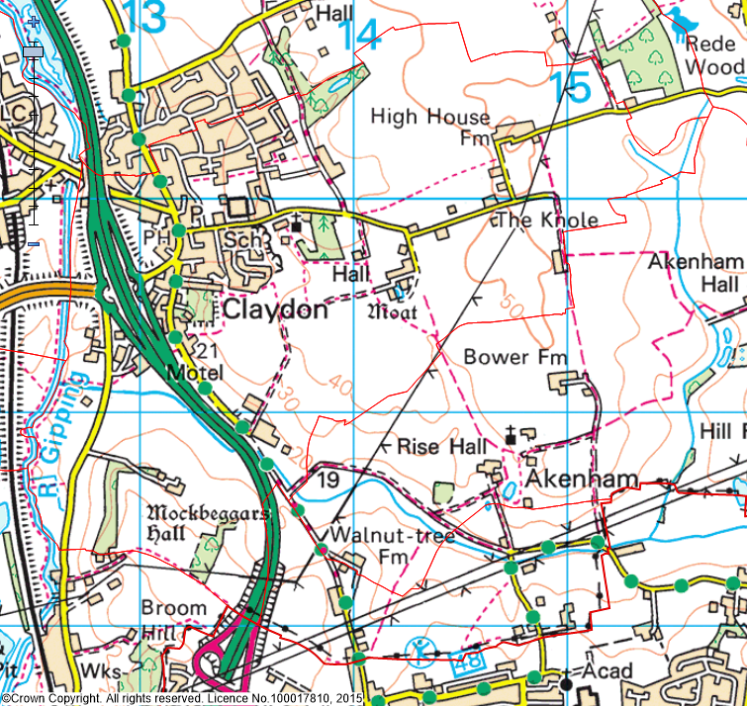
`
[Parish level]

(Last Updated: October 2019)

This Parish Profile has been produced primarily to help inform local discussion on housing need.
Most of the data comes from the 2011 Census (accessible via the ONS website). Other data sources have also been used as appropriate, and will be updated periodically.

How many people live locally? | Children Under  16 | Working  Age Adults  (16 to 64) | People  Aged  65 + | Dependency Ratio
2,197 | 425 (19.3%) | 1,325 (60.3%) | 447 (20.3%) | 0.66
Males: 50.5%  Females: 49.5% | Mid Sflk Avg = 18.4%  England Avg = 18.9% | Mid Sflk Avg = 61.5%  England Avg = 64.7% | Mid Sflk Avg = 20.1%  England Avg = 16.3% | Mid Sflk Avg = 0.63  England Avg = 0.55

[Source: ONS 2011 Census: KS101EW & KS102EW] [Dependency Ratio = Ratio of Non-working Age to Working Age Population]

Single Pensioner Households | Single H/holds  < 65 years old | Lone Parent Families  with Dependent Children
137 | 98 | 50
14.9% of all Households  Mid Suffolk Avg = 12.9%  England Avg = 12.4% | 10.6% of all Households  Mid Suffolk Avg = 12.4%  England Avg = 17.9% | 18.8% of all families with dependent children  Mid Suffolk Avg = 17.7%  England Avg = 24.5%

[Source: ONS 2011 Census: KS105EW]

General Health (All Usual Residents)

Very Good  47.9% | Good  34.1% | Fair  14.5% | Bad  2.7% | Very Bad  0.8%
Mid Sflk Avg = 47.9%  England Avg = 47.2% | Mid Sflk Avg = 35.3%  England Avg = 35.2% | Mid Sflk Avg = 12.8%  England Avg = 12.8% | Mid Sflk Avg = 3.1%  England Avg = 3.6% | Mid Sflk Avg = 0.8%  England Avg = 1.0%

[Source: ONS 2011 Census: QS302EW]

Total # Occupied  Households | Owned (Outright or with Mortgage) | Shared Ownership | Socially  Rented | Privately  Rented
922 | 748 (81.1%) | 3 (0.4%) | 99 (10.7%) | 64 (6.9%)
922 | Mid Sflk Avg = 75.1%  England Avg = 63.3% | Mid Sflk Avg = 0.8%  England Avg = 0.8% | Mid Sflk Avg = 11.3%  England Avg = 17.7% | Mid Sflk Avg = 11.2%  England Avg = 16.8%

[Source: ONS 2011 Census: QS405EW]
- At the time of the 2011 Census some 25 dwellings (2.6% of all dwellings in Claydon) appeared to be unoccupied. (Mid Suffolk Avg = 3.8%) [QS418EW]
Number of Bedrooms (Occupied Households)

None | 1 bed | 2 bed | 3 bed | 4 bed +
0 (0%) | 74 (8.0%) | 254 (27.6%) | 383 (41.5%) | 211 (22.9%)
Mid Sflk Avg = 0.1%  England Avg = 0.2% | Mid Sflk Avg = 6.0%  England Avg = 11.8% | Mid Sflk Avg = 25.0%  England Avg = 27.9% | Mid Sflk Avg = 40.4%  England Avg = 41.2% | Mid Sflk Avg = 28.5%  England Avg = 18.9%

[Source: ONS 2011 Census: QS411EW]

Total # Occupied  Households | Total # with Under-Occupied bedrooms | Total # with Over-Occupied bedrooms
922 | 728 (84.7%) | 14 (1.5%)
922 | Mid Sflk Avg = 80.8% / England Avg = 68.7% | Mid Sflk Avg = 1.6% / England Avg = 4.6%

[Source: ONS 2011 Census: QS412EW]

NET NEW RESIDENTIAL COMPLETIONS (Last 5 Years: April to March)
2013/14 | 2014/15 | 2015/16 | 2016/17 | 2017/18
1 | 0 | 0 | 0 | 0

[Source: Babergh & Mid Suffolk Joint Annual Monitoring Report]

Avg Price & No (in brackets) of Properties Sold in IP6 Postcode (Aug 2018)
Detached | Semi-detached | Terraced | Flat | All
£350,555 (9) | £242,699 (10) | £211,998 (10) | £0 (0) | £265.585 (29)

[Source: Right Move website: Market Trends]

Other Information

- County Councillor = Cllr John Field (Gipping Valley Division)

- District Councillor = Cllr John Whitehead & Cllr Timothy Passmore (Claydon & Barham Wards)

- Claydon (with part Barham) and Great Blakenham are identified as a Key Service Centre in Policy CS1 of the Mid Suffolk Core Strategy DPD (Adopted Sept 2008)

- Local Services in Claydon include … Schools, place of Worship, a General / Convenience Store, local pubs / restaurants and a mix of business units

- 84.4% of all households with at least one usual resident in Claydon have access to gas-fired central heating [QS415EW]

- The following Housing Association’s (Registered Providers) are known to be active in Claydon: Flagship & Orwell

- The 2014 Suffolk Housing Survey shows that, across Mid Suffolk district:

  - 12% of all existing households contain someone looking for their own property over the next 3 years (mainly single adults without children). The types of properties they are interested in are flats / apartments, and smaller terraced or semi-detached houses. Although this is not their first preference, many accept that the private rented sector is their most realistic option.

  - 25% of households think their current property will not be suitable for their needs in 10 years’ time.

  - 2 & 3 bed properties are most sought after by existing households wishing to move.

  - Suitable housing options for more elderly people are less available within the current housing stock. 6% of all households have elderly relatives who may need to move to Suffolk within the next 3 years.

